    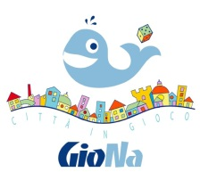 |   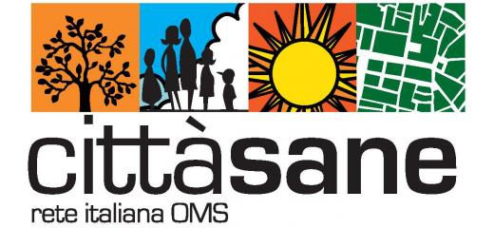 | 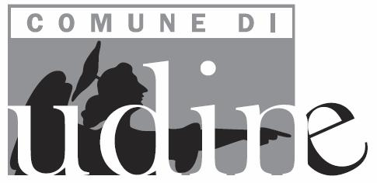  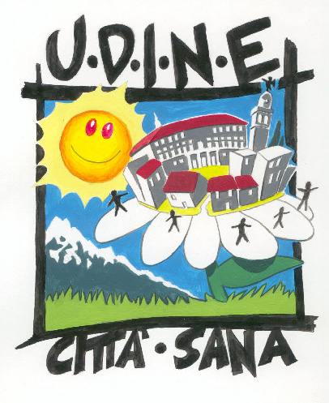 | 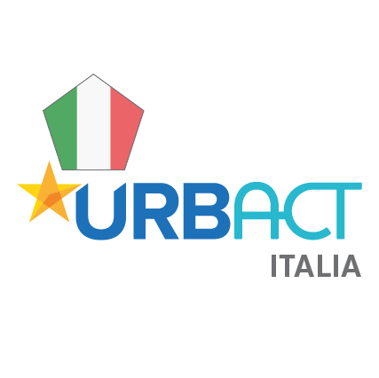

INFODAY URBACT III

Transfer Network Open Call

&

Udine Good Practice “The Playful Paradigm”

Thursday 7 December 2017, 9.00-16.00
Casa della Contadinanza – Castello di Udine
& Ludoteca – Via del Sale n. 21

The Municipality of Udine in collaboration with the Italian National Urbact Point will organise an Infoday meeting for those cities who intend to participate in the next Urbact III Transfer Network Call. The content of the Udine Good Practice “The Playful Paradigm”, presented by the Municipality and selected by the URBACT Team among 270 proposals in 29 European countries, will be addressed during the Infoday. This will foster the exchange of contact information and experiences between cities which already took part in the URBACT Programme and cities which will apply to an URBACT call for the first time.
The meeting is open to all those who are interested in the issue of games as tools for promoting participation, social inclusion, intergenerational relationships. Practical activities will be organized in the afternoon in the municipal toy library.

PROGRAMME

9.00–9.30 Participants’ registration & welcome coffee

9.30-9.45 Greetings & introduction
Furio Honsell, Mayor of Udine
Renata Bagatin, FVG Regional Councillor & Political focal point for the Regions for Health Network
Roberto Pella, Vicepresident ANCI Nazionale (National association of municipalities)
Simona Arletti, President of the Italian Healthy Cities Network
Giuseppe Napoli, Federsanità ANCI FVG

9.45-10.00 Presentation of the Italian National Urbact Point and Italian Good Practices in a nutshell
Simone D’Antonio, Anci – Italian National Urbact Point

10.00-10.15 Urbact III: Transfer Network Call
Ileana Toscana, Urbact Expert

10.15-10.45 The value of games and playing
Anna Ercoli, psychologist, holistic advisor and trainer for personal development and empowerment

10.45-11.15 Games for contrastic pathological gambling
Dario De Toffoli, Studiogiochi founder and expert in games

11.15-11.45 The Playful Paradigm: games as tools for promoting health, sustainability, social inclusion, healthy and active ageing, healthy lifestyles, resilience
Furio Honsell, Mayor of Udine & President of GioNA – Association of Playful Cities
Raffaella Basana, Councillor for Sports, education and healthy lifestyles, Municipality of Udine
Paolo Munini, Agnese Presotto, Stefania Pascut, Municipality of Udine

11.45-12.30 Questions & Answers

12.30-13.00 Take home messages and conclusions
Simone D’Antonio, Anci – Italian National Urbact Point

13.00-14.00 Lunch break

14.00-16.00 Visit to the Municipal Toy Library and practical activities

16.30 Closing of the meeting

Italian-English & English-Italian interpretation will be provided.

The meeting can be followed in live-tweetting through the Twitter account of the Italian National dissemination point @Urbact_it

Please confirm your participation: healthy.cities@comune.udine.it
Ask information to: Simone d’Antonio s.dantonio@anci.it
Agnese Presotto agnese.presotto@comune.udine.it
Stefania Pascut stefania.pascut@comune.udine.it

